**TECHNICAL COMPUTER CONCEPTS**

TCC: 2:03 pm 01/21/2023

Types of Personal Computers (MicroComputer)

> Smallest computer created

- Desktop:

: most common type of personal computer

: made/design for table/desk

: system you see around in schools, home, and offices

: as of today, desktop computer are more powerful in this generation

- Workstation

> Specialized Personal Computer

> Single user; more powerful, and more features than Standard PC4

> High resolution monitors and graphics

Mostly used by:

: Scientist

: Engineer

: Animators

- Notebook Computer(Laptop)

> More popular but less power than desktop computer

> Smaller size

> Operated by both alternating current and direct current battery

GPU:

Graphics Processing Unit

- Tablet

> Newest development in portable

> Full featured pc

> less performance

- Handheld/Mobile Device

> [PDA] Personal Digital Assistance

> Fits in your hand

> Mostly used by negotiators/corporators/companies

- Smartphone

> most used personal computer

> portable

Network

> connection between devices

Identifying the key parts of computer

Note:

Group Presentation *Reporting*

- 8 members

-

TCC W3 1:28 pm 01/28/2023

Identifying Key Parts of Computer:

> Motherboard:

- Backbone that ties the computer's components together at one spot and allows them to talk to each other

- main hub

: Standard-ATX (Advance Technology eXtended)

- pre-built computer system

: Micro-ATX

: Mini-ITX (Information Technology Extended)

: Nano-ITX

: Pico-ITX

- Smart phones (Handheld computer)

> Parts of Motherboard:

: PCi Express

- for Graphic Card/Video CArd

: Peripheral Component Interconnect

- external soundcard, landcard

; replacement for specific internal parts

: Earphone, Headphone, Audio Port

-

: Display Port:

- VGA, DVI, HDMI

IDE Connector/Cable (outdated) (Integrated Drive Electronics)

SATA Connector/Cable (Serial Advanced Technology Attachment)

: CMOS (Complementary Metal-Oxide SemiConductor)

- battery

: RAM Slot

- limited compatibility

CPU (Central Processing Unit)

- brain of computer system

- a computer hardware that carries out a computer's instructions and controls all the arithmetical, logical, and input/output operations of a computer system

- most important part of computer

- also known as micro processor/ central processor

Location:

- placed in the CPU socket center around the VRM section of the motherboard connected with the other hardware elements inside the computer cabinet

- situated under the Heat Sink to regulate temperature

VRM:

- Voltage Regulator Module

Intel 4004:

- world's first microprocessor invented by intel company

- March, 1971 (November 15)

- 4th generation

Function:

- store and process by performing all the mathematical and logical calculations with the input data to provide the output data to the users, thereby working on the computer

Input Device:

- keyboard

- mouse

- microphone

- scanner

- camera

- sensor

Data Storage: Processes and stores Cache for Future Use

- HDD

- SDD

- Memory Cards

- Pen Drives

- Optical Disks

Output Device:

- monitor

- printer

- speaker

- headphone

- screen projector

- plotter

Cycle:

1. Fetching

- receives basic instructions or series of binary numbers from RAM to CPU

2. Decoding

- data is loaded to CPU and performs logical and arithmetic operations

3. Executing

- decoded instructions will be execute, computer has to carry out the instruction during execution step

- loading and performing data from memory

Importance:

- Accountable for processing data

Brain:

- Manages functions throughout the whole system

Components:

- ALU (Arithmetic Logic Unit)

- CU (Control Unit)

- Registers

- Cache

- Busses

- Clock

Types:

- classified to cores

; single-core

; dual-core

; quad-core

; Hexa-core

; Octa-core

; Deca-core

- classified to architecture

Main Functions:

- Fetching

- Decoding

- Execution

2:26 pm 01/28/2023

Motherboard

-the backbone that ties computer’s components together at one spot and allows them to talk to each other.

Types:

* Standard-ATX
* Micro-ATX
* Mini-ITX(information technology extended)
* Nano-ITX
* Pico-ITX

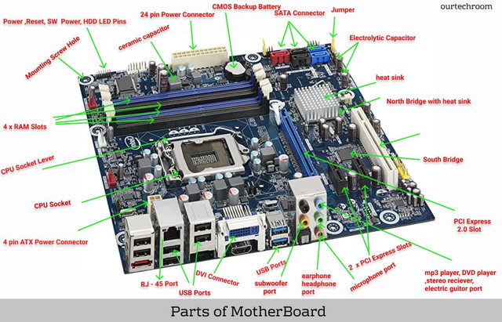

What is CPU?

* CPU or Central Processing Unit that carries out a computer’s instructions and controlls all the arithmetical ligical and input/output operations of a computer system.

1st microprocessor of intel: Intel 4004

Where CPU is located in the computer?

* This CPU is placed on the CPU around socket center around the VRM(Voltage Regulation Module) section of the motherboard connected with other hardware elements inside the **computer cabinet**.

What is the function of CPU in computer?

* The main function of CPU in the computer is to store and process by performing all the mathematical and logical calculations with the input data to provide the output data to the users, thereby working on the computer.

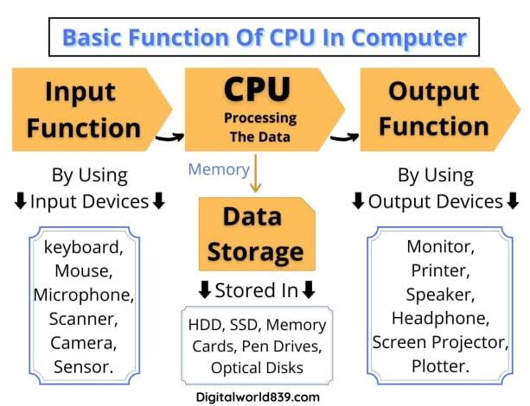

How CPU (Central Processing Unit) works?

1. Fetching
2. Decoding
3. Executing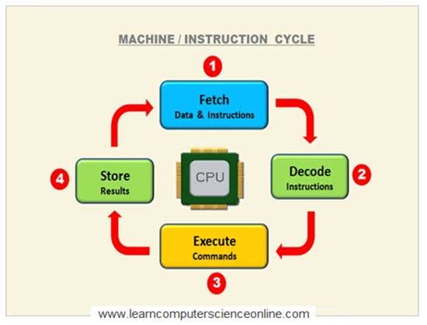

FAQ’s

* Why CPU is important?
* Why is rhe CPU called the brain of the computer?
* What are the components of CPU?

-ALU ,CU , Register, cache,buses, clock

* Types of CPU?

-Single-core, dual-core, quad-core, hexa-core and deca-core.

* What are the 3 main functions of CPU?
* Are CPU and processor the same
* Why CPU is situated under the heat sink?

*COMPUTER CASES/TOWERS*

**CONTINUATION:** Identifying key parts of a Personal Computer

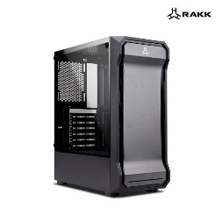

What is PC Case?

* The computer cases are a visible part of our computers called PC towers and Computer towers. Its function is to serve as a protective structure for the rest of the internal components where they will be assembled.

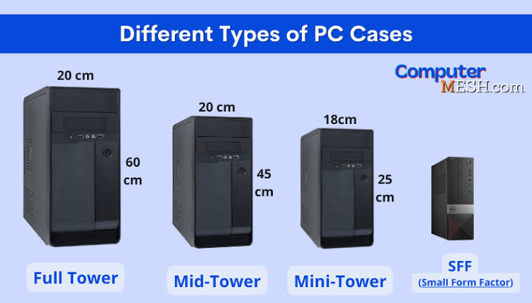**4 Different types of Computer Cases**

**FULL TOWER**

-Full Tower is used to accommodate an **E-ATX** (Extended-Advance Technology eXtended) **or CEB (**Compact Electronics Bay Specification) **motherboard**

* **E-ATX** = 13” instead of 9.6”
* **CEB** = 12” x 10.5”
* Full tower size 55-75cm tall and 22-32cm width

**MID TOWER**

-the most popular and widely used computer case that allows you to use many drives and almost all types of motherboards with acceptable overall dimensions in it.

* Mid tower size 35-55cm tall and 15-25cm width

**MINI TOWER**

-designed to take up as little physical space and without Installing decent-sized graphics cards

* Mini tower size 30-45cm tall and 15-25cm in width

**SFF (SMALL FORM FACTOR)**

-These types of cases were considered very niche, but in recent years they have gained popularity due to the miniaturization of powerful components that can fit in them.

**Power on Self Test**

***What is POST (Power on Self Test) in computers?***

The Power On Self Test, or POST, is a diagnostic procedure that a computer performs when it boots up and is stored in the ROM BIOS on the motherboard.

Using POST to recognize failures

* + Beeps sound
  + Messages displayed on the monitor screen
  + Hexadecimal error codes issued on the / O port

**Tests of *Power on Self Test***

* CPU register test,
* ROM checksum test,
* System timer and beeper port test,
* Checking the DMA controller,
* Reviewing the lower region of RAM for projecting resident programs in the BIOS,
* Launch of local programs,
* Checking the standard graphics adapter (VGA),
* Testing RAM,
* Checking the main input devices,
* CMOS check,
* Checking the main LPT / COM ports,
* Checking hard disk drives (HDD), and SSDs,
* Self-testing of BIOS functional subsystems,
* Transferring control to the bootloader.

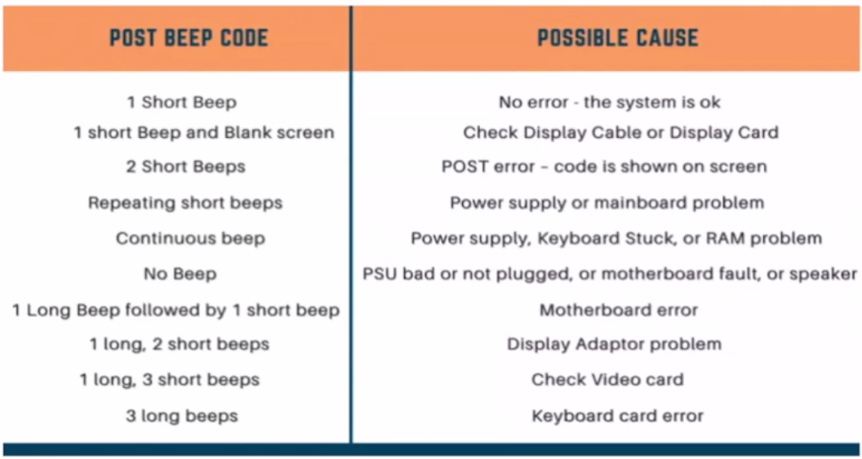

|  |  |
| --- | --- |
| POST BEEP CODE | POSSIBLE CAUSE |
| 1 Short Beep | **No error - the system is ok** |
| 1 Short Beep and Blank screen | **Check Display Cable or Display Card** |
| 2 Short Beeps | **POST error - code is shown on screen** |
| Repeating short beeps | **Power supply or mainboard problem** |
| Continuous beep | **Power supply. Keyboard Stuck. or RAM problem** |
| No Beep | **PSU bad or not plugged. or motherboard fault. or speaker** |
| 1 Long Beep followed by 1 short beep | **Motherboard error** |
| 1 long 2 short beeps | **Display Adaptor problem** |
| 1 long. 3 short beeps | **Check Video card** |
| 3 long beeps | **Keyboard card error** |

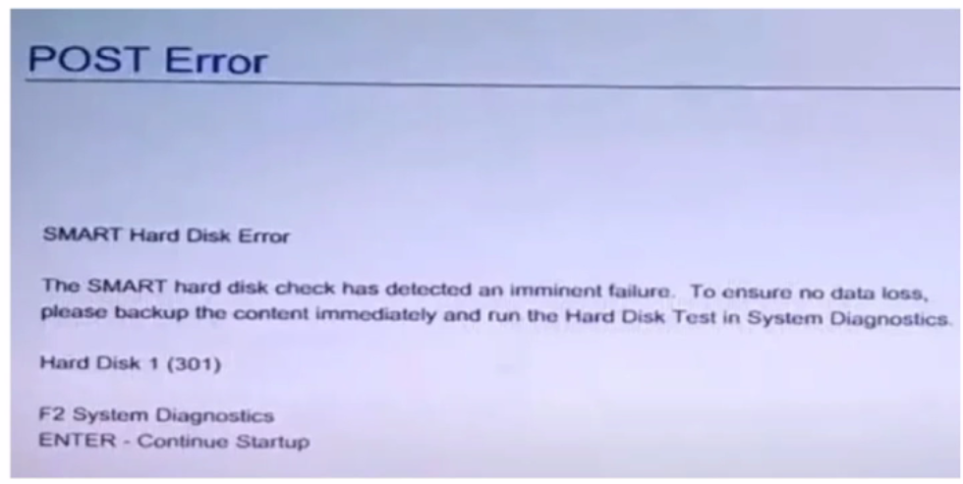

|  |  |
| --- | --- |
| Error Code | Possible Cause |
| 301 | Indicates the hard drive is failing |
| 201 or 203 | Memory module failure detected |
| 1101 | Malfunction in your system operation or failed installation of software, or **system crashing** |
| 601 | Battery error or dead |
| 161 | Irregular entries in the Windows registry or in configured system |

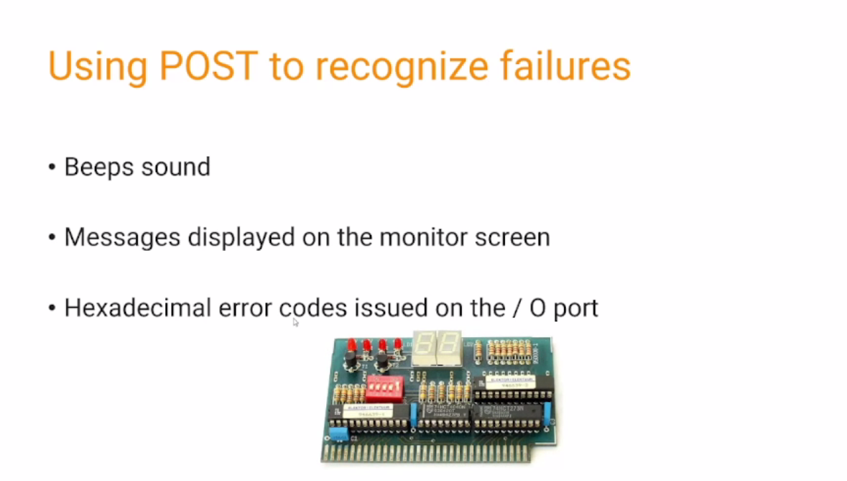

Expansion slot

3 basis post card made

* **ISA slot** > x86 architecture
* **PCI slot** > x86 architecture (power CPUs)
* **AGP slot** > x86 architecture

Standard steps to resolve errors if you are getting some sort of error in the post code you can try suggestions and look at if they solved the issue

* Restart
* Unplug any drives or USB devices.
* Disconnect external devices.
* Reconnect the power supply cables.
* Identify the beep code using the component or device manual.
* Check the fans turned off or on.
* Disconnect all expansion cards.
* Power off and on the computer.
* Check if the BIOS chip is loose.
* Update BIOS.
* Change motherboard, GPU, RAM, PSU, storage disks as a proxy to see whether the POST continues to proceed further.

**TECHNICAL COMPUTER CONCEPTS [4th Quarter]**

**Primary Memory in Computer**

Examples, Types, And Characteristics

**What is Primary Memory of Computer?**

The primary memory processes the data and instructions while the computer unit is processing.

Primary memory stores the data or instructions for quick access. Semiconductor chips are the main component used in primary memory.

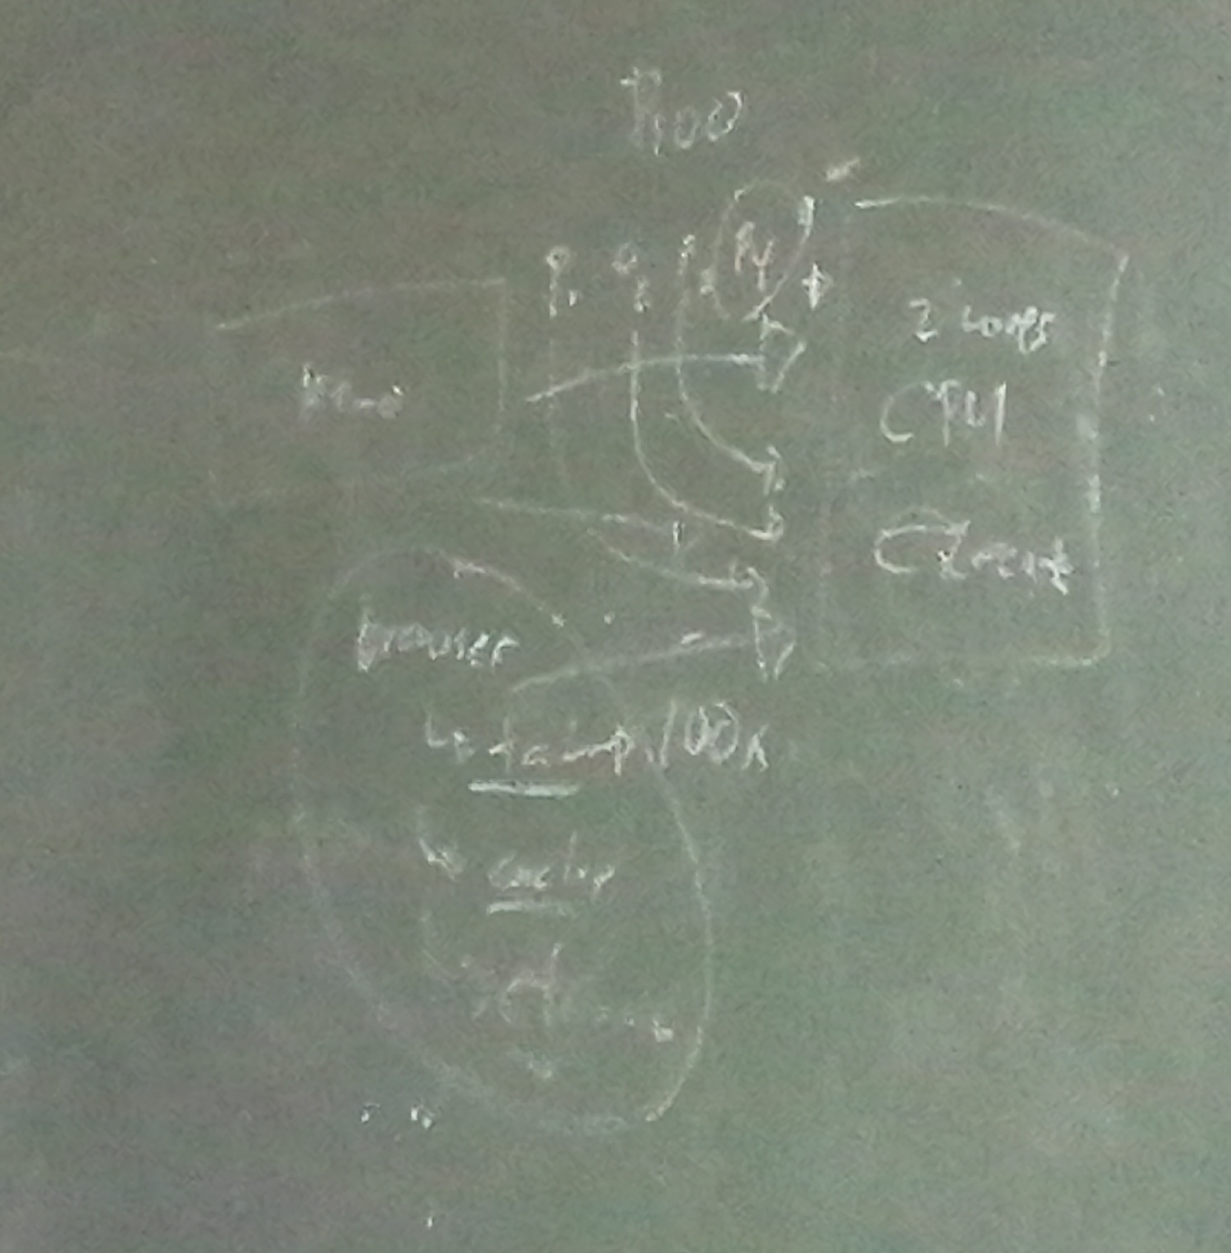

**What are the Primary memory’s Characteristics?**

* It is volatile memory.
* This memory is made of semiconductors technology
* Data is automatically deleted in the event of power failure.
* The processing speed is faster than secondary memory.
* This is the main working memory of the computer.
* 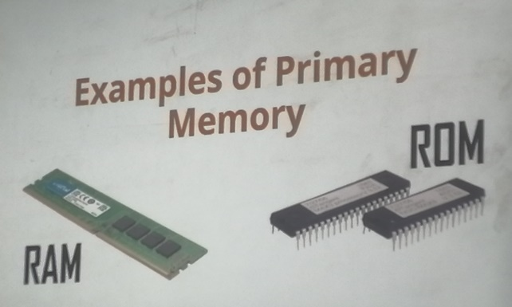A computer is not able to process without primary memory.

**Examples of Primary Memory**

* RAM
* ROM

**Power outage**

**What Is a Power Outage And A Power Surge?**

The scenario (lights flickering and then electricity going out) shows 3 main types of electricity anomalies:

The most obvious one is the power outage, also known as a blackout. A blackout occurs when the power is completely cut off. It happens for several reasons, including power station disruptions, damaged electrical lines, load-shedding, or self-inflicted damage – such as short-circuiting.

Lights flickering 2 possible reasons:

* wasn’t enough power available, causing a brownout
* A power surge occurs when there is an excessive amount of electricity comes from the socket source.

**How Do Power Outages or Power Surges Damage Your PC Components?**

There’s a reason our PCs have the shutdown option. They are designed to go through a series of processes before turning off. Therefore, a direct power outage or a power surge can be damaging in some circumstances, and in others, they will leave your system unscathed.

1. **Effect On PSU – The Self Sacrificial Heroes**

* In a situation where your PC faces an electrical anomaly, your PSU will offer the first line of defense. It will cover the unit and cut off the power supply to prevent damage.
* In the worst-case scenario, you’ll hear a loud band, and the PSU will self-destruct first, preventing damage from spreading to the rest of the system. This also happens when a [PSU lifespan](https://digitalworld839.com/how-long-do-power-supply-unit-last/) is nearing the end.
* If your computer won’t turn on after the PSU has caused a power outage, there is still hope. You can remove the power supply’s “dirty power” by leaving the system off for several hours (or a few days, to be sure). Meanwhile, you may test another PSU to ensure your PC is safe.

**Note** – There is one condition that must be met in order for the PSU to fulfill its potential as a savior. A good PSU from reputable manufacturers should be used. That is why installing cheaper power supply units, either [modular or non modular](https://digitalworld839.com/what-is-modular-and-non-modular-power-supply/) is never suggested.

1. **Effect on System Files**

* This is probably the nastiest effect of a sudden shutdown. Although it doesn’t cause hardware damage, so you don’t have to worry about replacement costs, it can cost you in terms of hours. And if it were billable hours, well, then it does cost you moneywise.

**For example**, suppose the power goes out during normal usage. In that case, you will most likely be greeted with the familiar disk check screen when you power on or [restart the PC](https://digitalworld839.com/how-often-should-you-restart-your-computer/), which is good.

1. **Effects on Storage Devices**

**Hard Disk Drives (HDD)**

HDDs suffer from sudden power outages and face a reduced life expectancy. The reason is that a sudden power cut brings the spinning disc to an abrupt and uncontrolled stop. Furthermore, the reading and writing head (which hovers over the spinning platters) has to quickly snap back into place.

* This snapping makes it susceptible to a “head crash,” which occurs when the head touches the platter surface, scrapping the area. The scrapped part can no longer record data, leading to crashes and slowdowns, eventually declining the HDD durability.

**Solid State Drives (SSD)**

* The result of power outages on SSDs is difficult to generalize. It might be affected or not. As compared to HDDs, older SSDs were much more vulnerable, and the impact ranged from data corruption to system failure.
* Fortunately, manufacturers have realized this issue and introduced a new safety feature called PLP (Power Loss Protection) Mechanism.
* PLP protects the data in the buffer from complete loss, as SSD does not have enough time to complete its tasks in case of unexpected shutdowns. This is accomplished with the help of capacitors on the SSDs that provide just enough time for the data to be flushed to long storage.
* However, SSDs have a limited life span. When they reach the end of their useful lives, SSDs are reset to zero regarding data loss or corruption. As a result, an outage may or may not cause SSDs to deteriorate.

**Primary Memory – RAM**

* RAMs aren’t affected due to power outages or surges. It is because multiple components will be affected before the RAM gets its turn. First, the PSU will die, then the motherboard (that too in some infrequent instances), and then the [primary memory – RAM](https://digitalworld839.com/what-is-primary-memory-of-computer-examples/).
* If [RAMs memory life](https://digitalworld839.com/how-long-does-a-ram-last/) damages, they usually include a lifetime manufacturer’s warranty. So, you can just claim its warranty and get a replacement.

**What Are the Symptoms of a Computer Power Surge?**

* Your PC isn’t turning on,
* You are facing trouble while booting up your system (stuck in a boot loop and reboots spontaneously),
* The fans are making a strange noise or are spinning very fast,
* PC is suspiciously overheating,
* You get electrical shocks when you touch the computer case,
* The PSU is failing and isn’t working at all.

The surge protectors limit the voltage beyond a set limit. And if the voltage exceeds the capacity, they burn themselves out, breaking the circuit between the wall socket and the PC.

Why You Should Get A UPS?

Surge protectors do protect your PC in case of power surges, but they don’t do much in a sudden shutdown. This is where UPS can help and is always recommended with a PC.

The UPS isn’t meant to keep your PC on the entire duration of a power outage, but they serve several important purposes. They supply battery backup for a few crucial minutes for you to save your work and safely shut down the system.

In addition, it serves as a two-in-one device by also acting as a surge protector. The UPS’ list of functions does not end there. It also serves the purpose of supplying clean and evened-out power, so you don’t face the small (unhealthy) drops in power when you turn on the AC.

The best part? The UPSs are totally worth it since they are going to be protecting a system that is worth 5x, maybe even 10 times their cost.

Power outages and power surges both are harmful to your computer. However, it is the power surges you need to really worry about.

They can cause problems ranging from a suspicious behavior of your computer to a complete loss of a component. Likewise, a power outage can cause nasty problems such as loss of data or data corruption, setting you back on hours of work. In some cases, a reinstall of windows might also be required.

Modern hardware and software, thankfully, are built with some concern for power outages and voltage spikes in mind. Repeated exposure, however, will undoubtedly damage in some form.

Because of this, it is always recommended to have a computer UPS or, at the very least, a surge protector. They are less expensive than you may think, especially considering the crucial purpose they serve.

It’s possible that an electrical problem will leave your PC unharmed. The risk of pushing your luck, however, is not worth it. Specifically when considering there is some damage in the long-term.